Task 3: Networking Basics for Cyber Security

Tool: Wireshark
Deliverables:
- Packet capture file (.pcapng)
- Analysis report
- Screenshots
- GitHub repository
Step 1: Basic Networking Concepts
- IP (Internet Protocol): IP provides logical addressing and routing so data packets can travel from a source device to a destination across networks.
- MAC (Media Access Control): A MAC address is a unique physical identifier assigned to a network interface for communication within a local network.
- DNS (Domain Name System): DNS translates human-readable domain names into IP addresses so devices can locate servers on the internet.
- TCP (Transmission Control Protocol): TCP ensures reliable, ordered, and error-checked delivery of data between devices.
- UDP (User Datagram Protocol): UDP enables fast, connectionless data transmission without guaranteed delivery or order
Step 2: Install Wireshark (Windows)

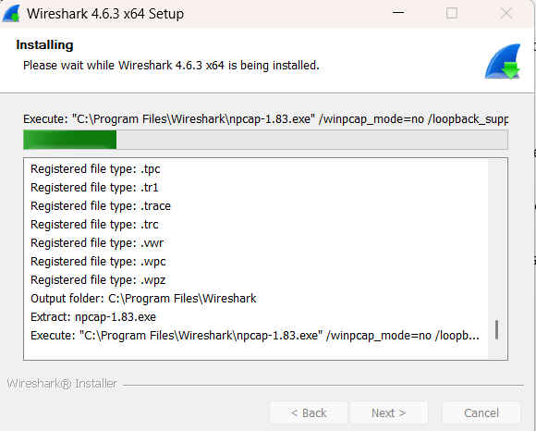
Step 3: Capture Live Network Traffic
1. Open Wireshark.
2. Pick your active interface (Wi-Fi or Ethernet).
3. Hit Start (the blue shark fin).
4. In your browser, visit:
- http://example.com
- https://google.com

Screenshot #2:
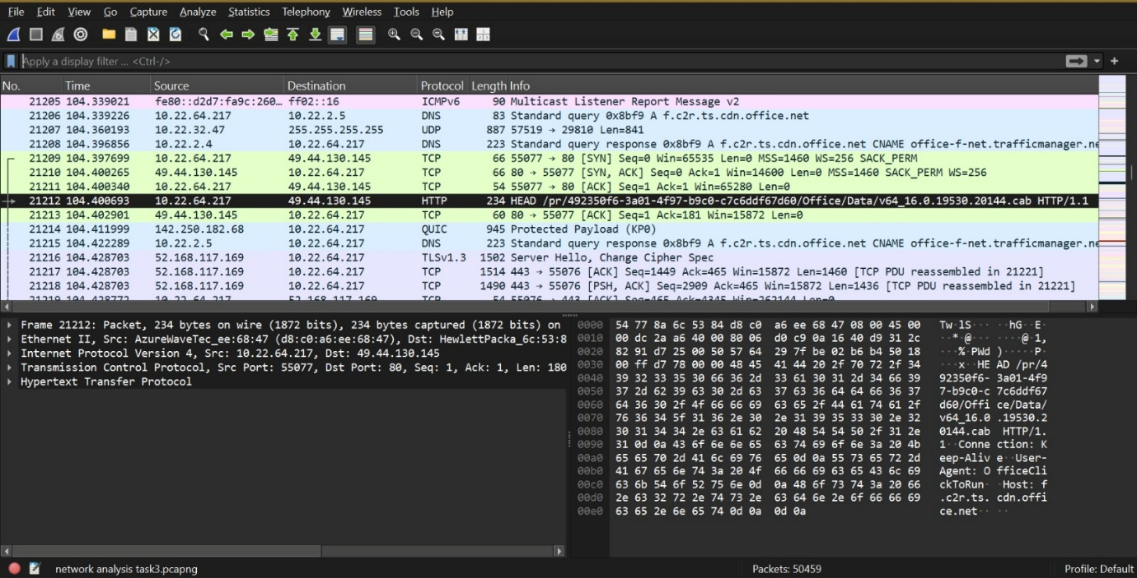

Step 4: Filter Packets by Protocol
Use these filters one at a time in Wireshark:
- tcp
- dns
- http

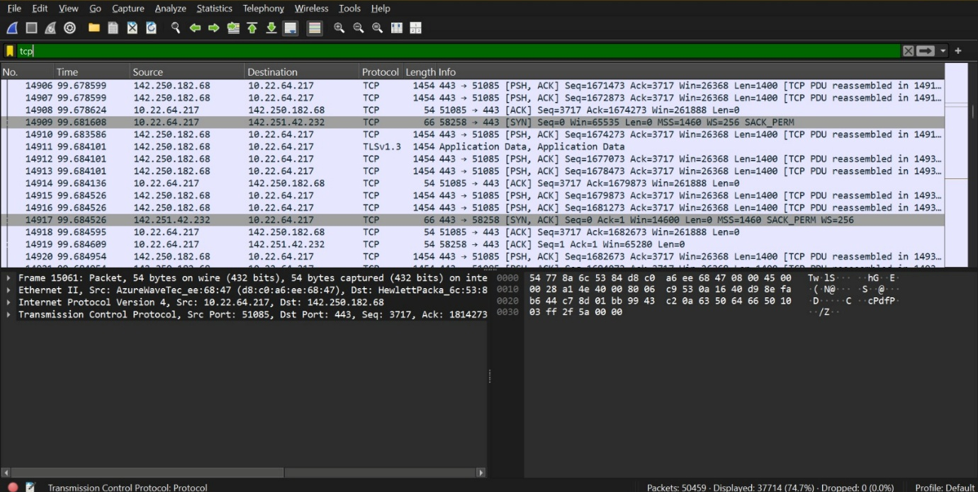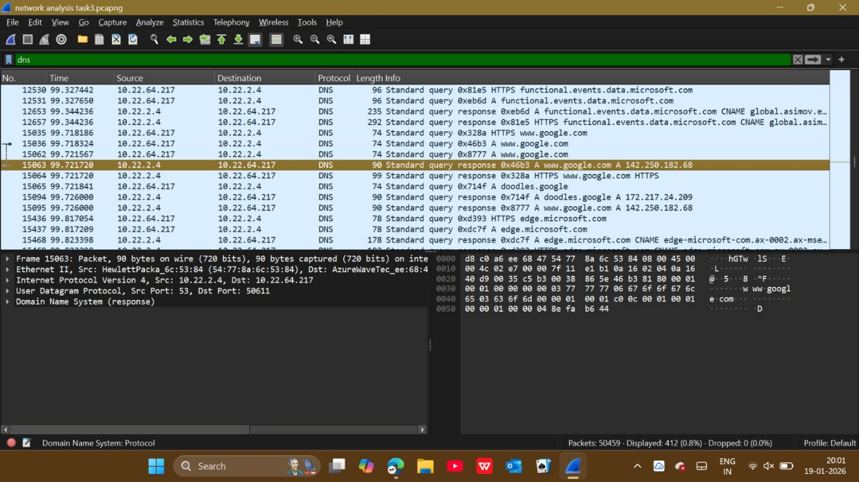
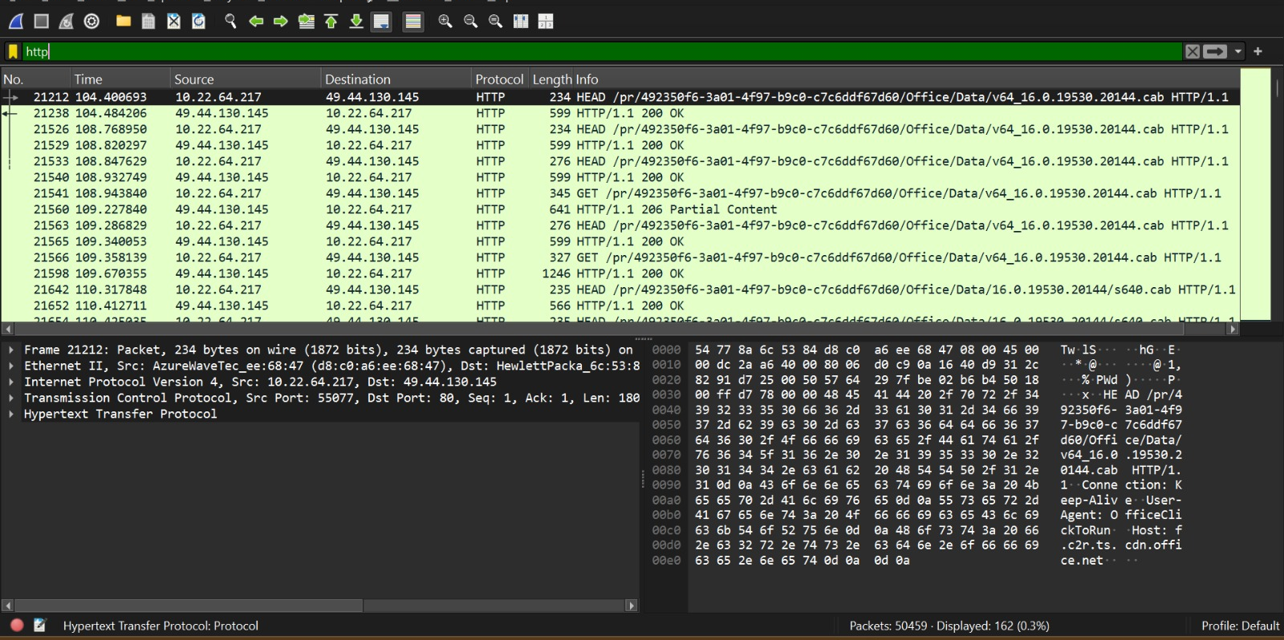
Step 5: Watch the TCP Three-Way Handshake
Apply this filter:
tcp.flags.syn == 1
Look for the SYN, SYN-ACK, and ACK packets.
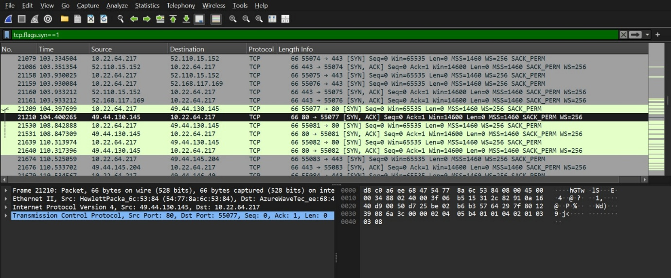
Highlight the TCP handshake packets.

Step 6: Spot Plain-Text vs Encrypted Traffic
1. Open http://example.com (plain text).
2. Open https://google.com (encrypted).
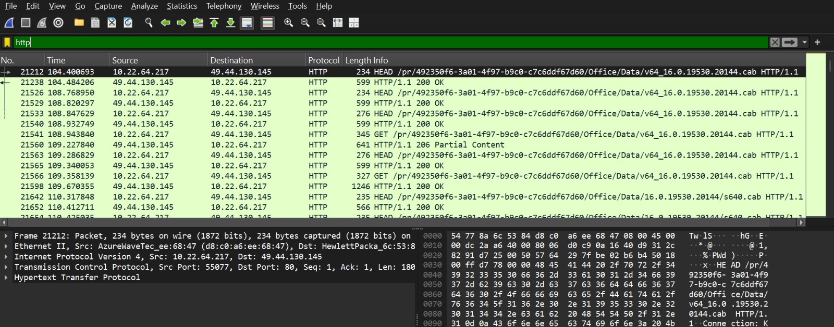
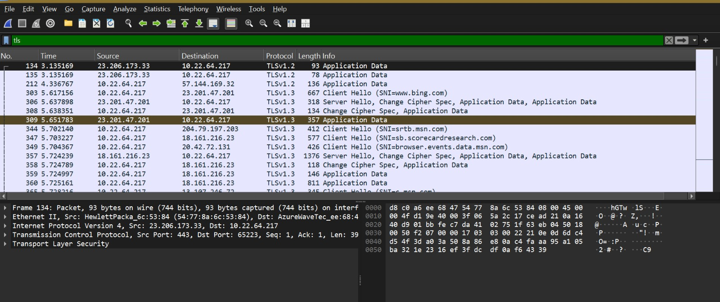
Step 7: Capture and Analyze DNS Queries
Use the filter:
Dns
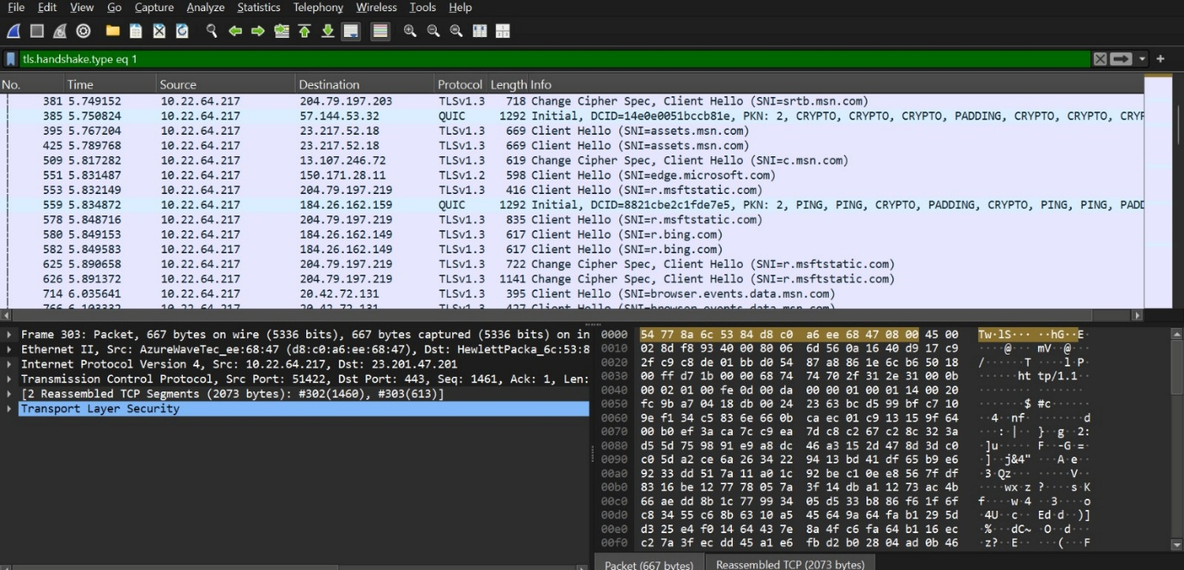
Screenshot #8:
Show DNS query and respons
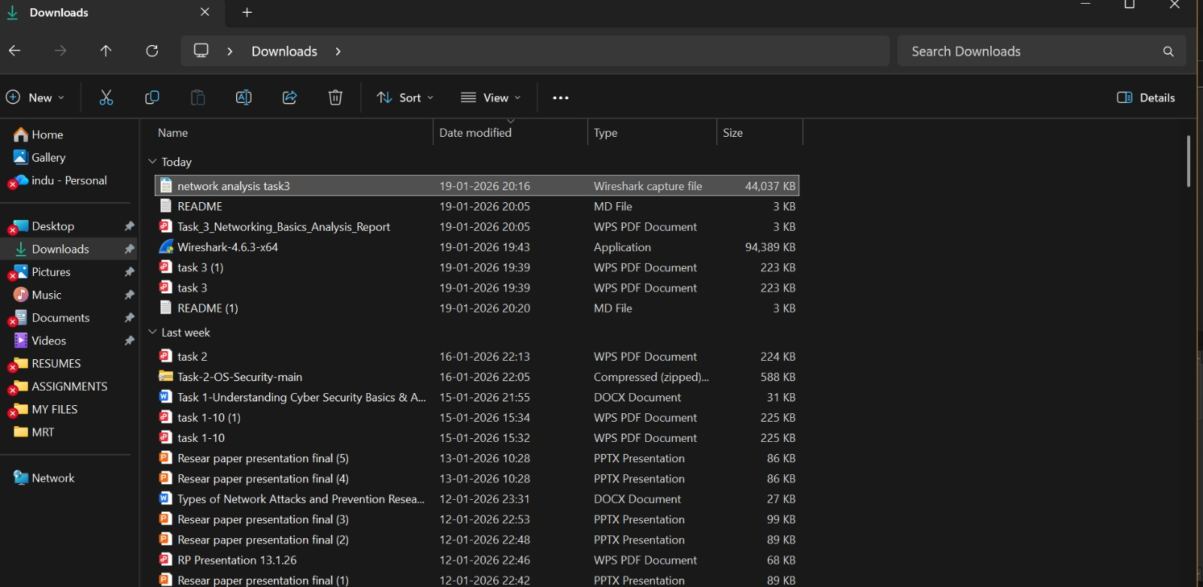

Observations:
- Different types of network packets can be seen when capturing live traffic.
- TCP packets show a connection setup using a three-step handshake.
- DNS packets reveal the websites being requested by the system.
- HTTP traffic shows data in plain text, while HTTPS traffic is encrypted.
- UDP packets are faster but do not confirm delivery of data.

Conclusion:
This experiment helped in understanding basic networking concepts and how data travels across a network. By analyzing packets, it became clear how different protocols like TCP, UDP, and DNS function in real time. The activity also highlighted the difference between encrypted and unencrypted traffic, emphasizing the importance of network security.

